

**REPUBLIC OF CAMEROON**

**Peace-Work-Fatherland**

**MINISTER OF HIGHER EDUCATION**

**FACULTY OF ENGINEERING**

**AND TECHNOLOGY**

**REPUBLIQUE DU CAMEROON**

**PAIX-Travail-Patrie**

**MINISTRE DE L’ENSEIGNEMENT SUPERIEUR**

**FACULTE DE L’ENGINERIE**

**ET TECHGNOLOGIE**

***\*\*\*\*\*\*\*\*\*\*\*\*\*\*\*\*\*\*\*\*\*\** UNIVERSITY OF BUEA *\*\*\*\*\*\*\*\*\*\*\*\*\*\*\*\*\*\*\*\*\*\*\*\*\****

**DEPARTMENT OF COMPUTER ENGINEERING**

**COURSE: INTERNET PROGRAMMING (J2EE) AND MOBILE PROGRAMMING**

**COURSE CODE: CEF 440**

**TASK 5: UI DESIGN AND IMPLEMEMTATION**

**PRESENTED BY**

**GROUP 20**

**INSTRUCTOR: DR. VALERY JUNE 2024**

**GROUP MEMBERS**

|  |  |  |
| --- | --- | --- |
| S/N | **Name** | Matricule Number |
| 1 | DUESENBERRY MBIKANG AGBORTAR AKO | FE21A175 |
| 2 | FOTABONG FUALEFAC PUISSANCE | FE21A195 |
| 3 | ABANGMA ARRAH JESUS MCLOUIS | FE21A124 |
| 4 | TABOT JOEL EBANGHA | FE21A308 |
| 5 | EBOMESUMBE NGOLE DANDY BRADLEY | FE21A177 |

Table of Contents

1. Introduction 3

1.1 Overview of Disaster Management System 3

1.2 Objectives of the Mobile Application 3

2. UI Design Process 3

3. Figma as a Design Tool 4

3.1. Welcome Screen 4

3.2 Home screen 6

3.3 Signup Screen 7

The signup screen enables new users to create an account by entering their details: 7

3.4 Login Screen Design 8

3.5. User Dashboard Design 9

3.5.1 Ambulance Contacts Screen 9

3.5.2 Fire Rescue Contacts Screen 10

3.5.3 Hospital Contacts Screen 11

3.5.4 Police Contacts Screen 12

3.5.5 Alerts Screen 13

3.5.6 Safety Tips Screen 14

3.5.7 First Aid Tips Screen 15

3.5.8 News Screen 16

3.5.9 Emergency Preparations Screen 17

3.5.10 Report Status Screen 18

3.6 Respondents Dashboard Design 19

3.6.1 Send Reports Screen 20

3.6.2 Contact Teams Screen 20

3.6.3 See Alerts Screen 21

3.6.4 User Status and Location Screen 22

3.7 Authorities Dashboard Design 23

3.7.1 Send Alerts Screen 23

3.7.2 Issue Directives Screen 24

3.7.3 Contact Teams Screen 25

3.7.4 Reports Screen 26

4. UI Implementation Strategy 27

5. Coding 27

6. Conclusion 28

7. Technologies 28

# 1. Introduction

In the face of increasing natural and man-made disasters, the need for effective disaster management systems has never been more critical. This report provides a detailed analysis of the UI design and implementation for a mobile application dedicated to improving disaster management. The application aims to enhance communication and response efficiency among users, respondents, and authorities during emergencies

## Overview of Disaster Management System

Disaster management involves a systematic approach to handling emergencies, focusing on preparedness, response, and recovery. The mobile application integrates functionalities across these phases to ensure users receive timely information, can contact emergency services, and report incidents efficiently. The app's design ensures accessibility and ease of use for all stakeholders involved.

## 1.2 Objectives of the Mobile Application

The mobile application for disaster management has several key objectives:

* **Improving Communication**: Facilitate effective communication between users, respondents, and authorities.
* **Providing Critical Information**: Ensure users have access to essential safety tips, emergency contacts, and alerts.
* **Streamlining Incident Reporting**: Enable quick and accurate reporting of incidents to appropriate responders.
* **Enhancing Coordination**: Support respondents and authorities in managing and coordinating their efforts during disasters.

# 2. UI Design Process

The UI design process for the disaster management mobile application follows a structured approach:

* **Requirement Gathering**: Engage with potential users, respondents, and authorities to understand their needs and preferences.
* **Wireframing**: Develop basic layouts for each screen, focusing on functionality and user flow.
* **Prototyping**: Create interactive prototypes using Figma to visualize the user experience and gather feedback.
* **User Testing**: Conduct usability testing with a diverse group of users to identify and resolve any issues.
* **Iteration**: Refine the designs based on feedback and testing results to ensure the final product meets user expectations.

# 3. Figma as a Design Tool

Figma was chosen for the UI design due to its robust features and collaborative capabilities:

* **Real-Time Collaboration**: Multiple designers can work on the same project simultaneously, making it ideal for team-based design work.
* **Prototyping Capabilities**: Figma allows the creation of interactive prototypes, helping visualize user flows and gather feedback.
* **Accessibility**: Being a cloud-based tool, Figma ensures that design files are easily accessible from anywhere.
* **Design Consistency**: Figma supports the creation of design systems and component libraries, ensuring consistency across the application.

The app contains multiple screens which are meant for particular tasks, these screens include

## 3.1. Welcome Screen

The welcome screen is the entry point of the application, designed to create a positive first impression, components of the design screen include:

* **Elements**: App logo, brief introduction, and navigation option (get started).
* **Design Focus**: Simplicity, clear navigation, and engaging visuals to attract users.
* **User Experience**: Ensures users can easily understand the app's purpose and navigate to the next steps.

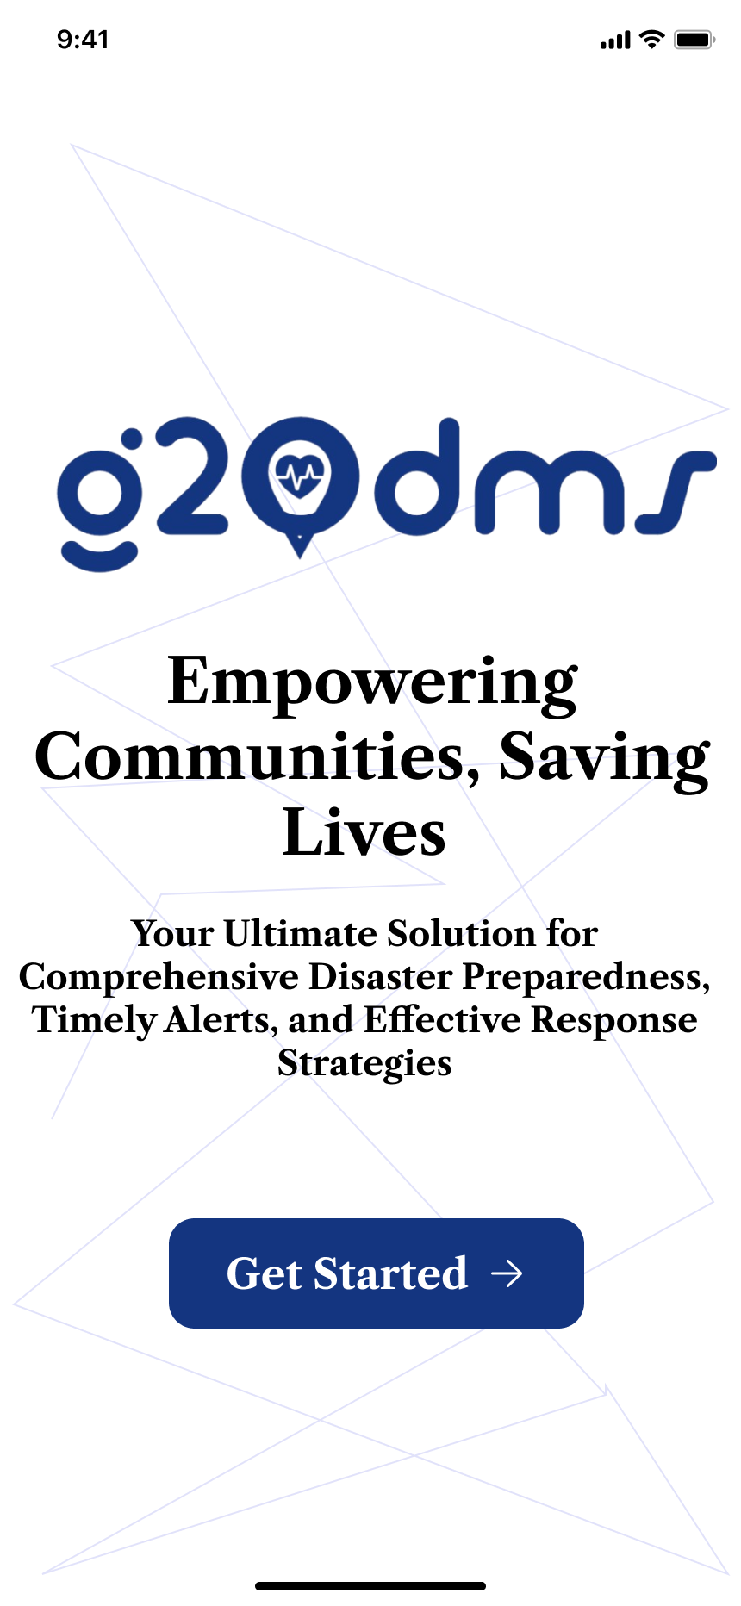

## 3.2 Home screen

After you click the get started option you are directed to the welcome screen where you select the role you want, the screen looks as follows;

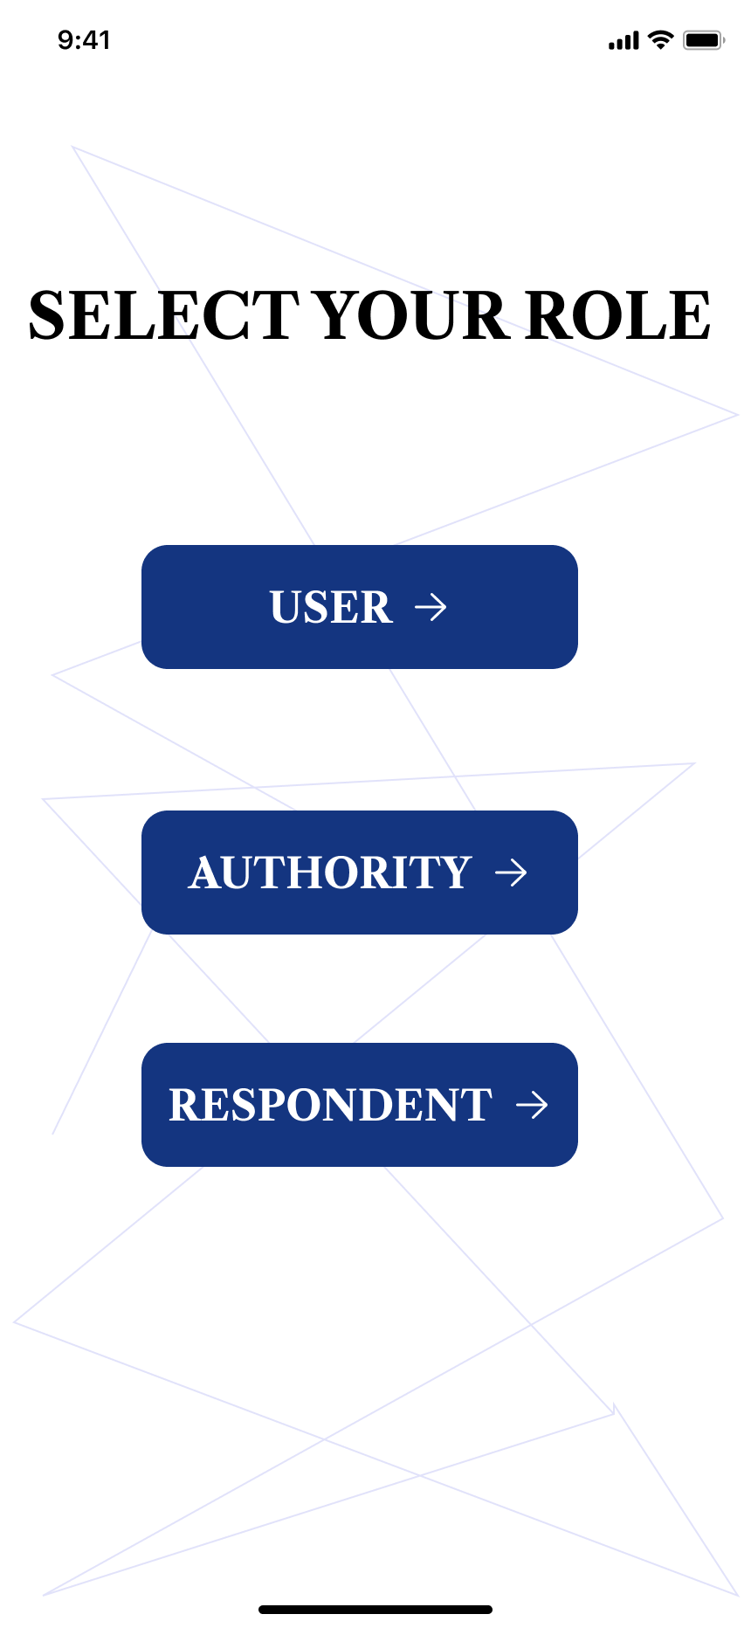

Based on the option selected from this screen you are directed to the signup screen.

## 3.3 Signup Screen

The signup screen enables new users to create an account by entering their details:

* **User Input Fields**: Name, email, ID number, password, mobile number
* **Design Focus**: User-friendly form layout, clear instructions, and validation messages.
* **User Experience**: Streamlined signup process to reduce friction and encourage user registration.

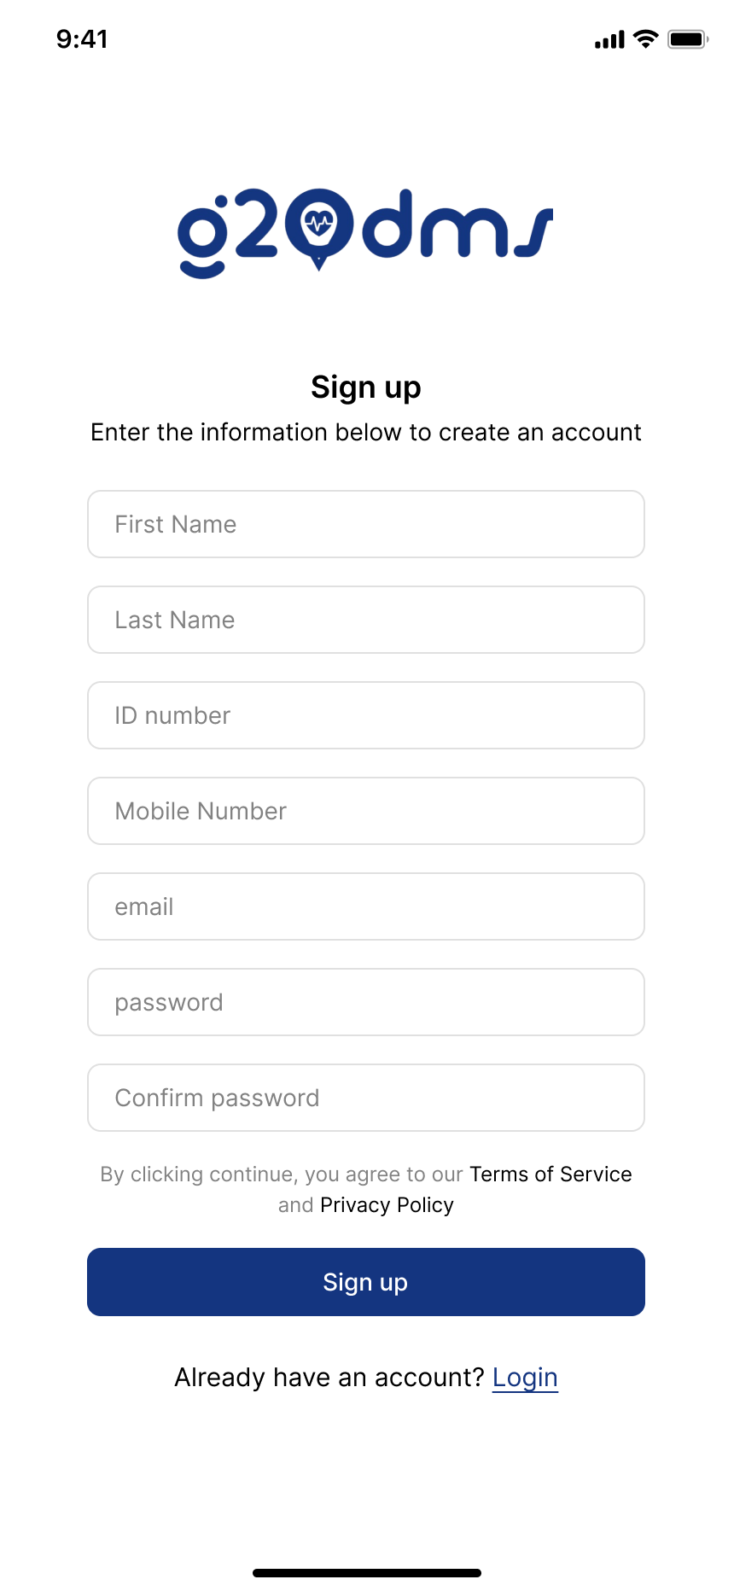

Below the input fields is a writeup which says “Already have an account?, login”. For already registered people, when they click on login it directs them to the login screen.

## 3.4 Login Screen Design

The login screen allows existing users to access their accounts:

* **User Input Fields**: ID number and password.
* **Additional Options**: Forgot password link and navigation back to the signup screen.
* **Design Focus**: Security, ease of use, and quick access.
* **User Experience**: Ensures users can log in quickly and securely.

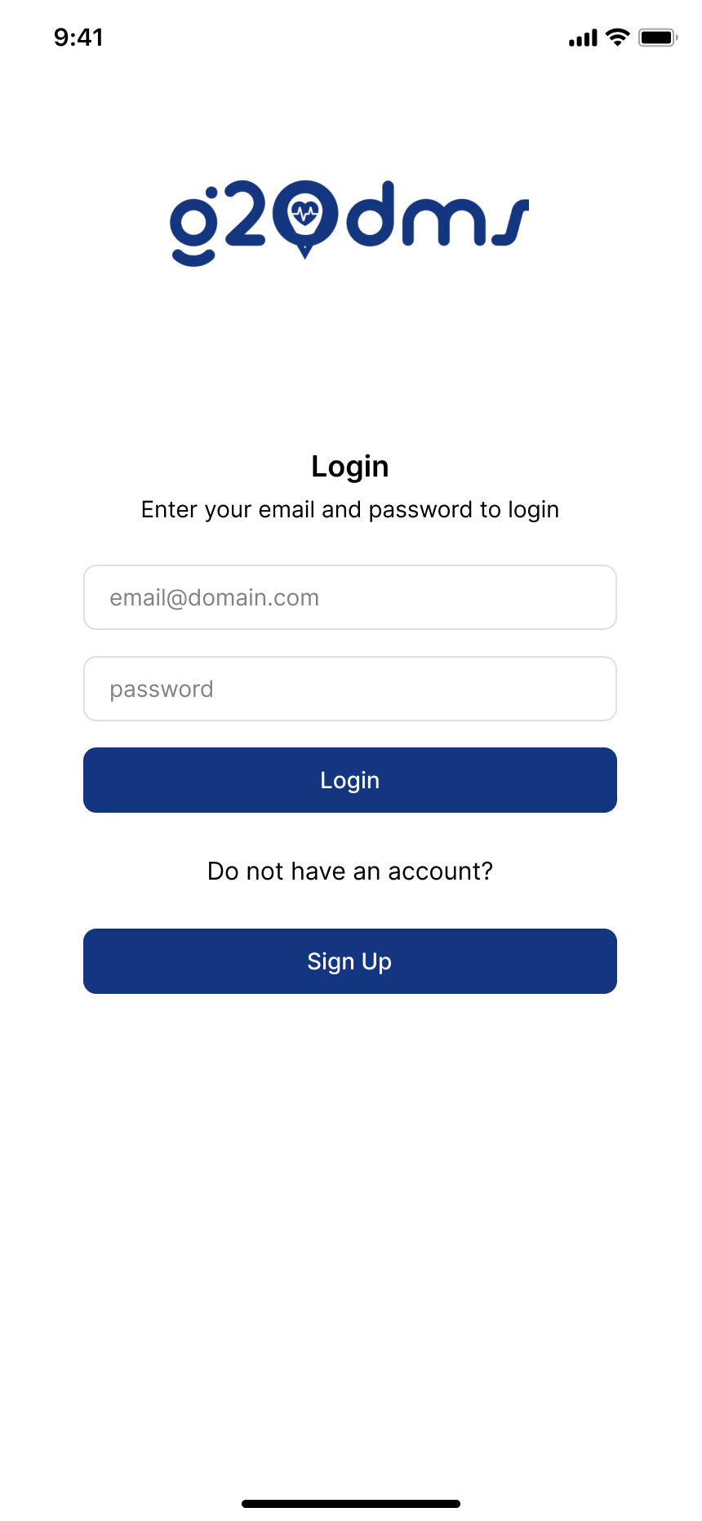

After either signing up or logging in, based on your option, you are re directed to its dashboard, now the dashboard for each entity is different;

## 3.5. User Dashboard Design

The user dashboard provides access to various screens essential for personal safety and emergency management:

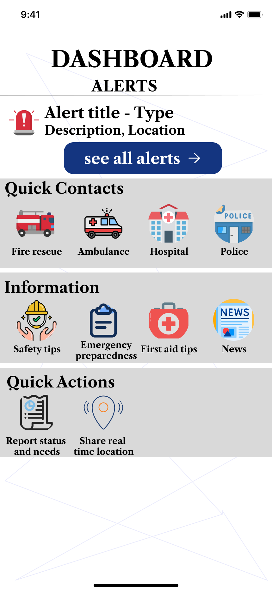

### 3.5.1 Ambulance Contacts Screen

This screen lists contacts for ambulance services:

* **Elements**: List of ambulance service providers with contact buttons.
* **Design Focus**: Quick access to critical emergency contacts.
* **User Experience**: Ensures users can call for medical emergencies without delay.

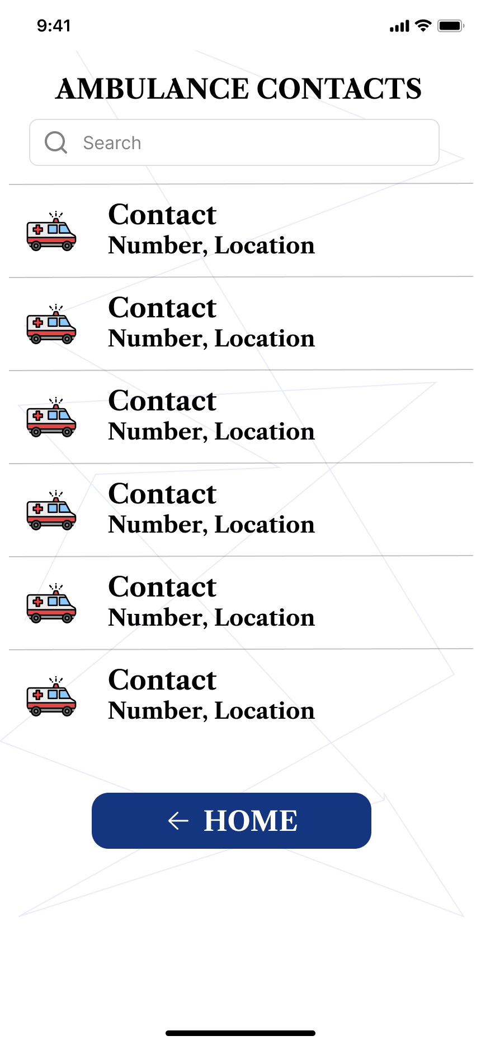

### 3.5.2 Fire Rescue Contacts Screen

This screen provides contacts for fire rescue services:

* **Elements**: List of fire rescue providers with contact buttons.
* **Design Focus**: Immediate access to fire rescue services.
* **User Experience**: Facilitates quick reporting of fire incidents.

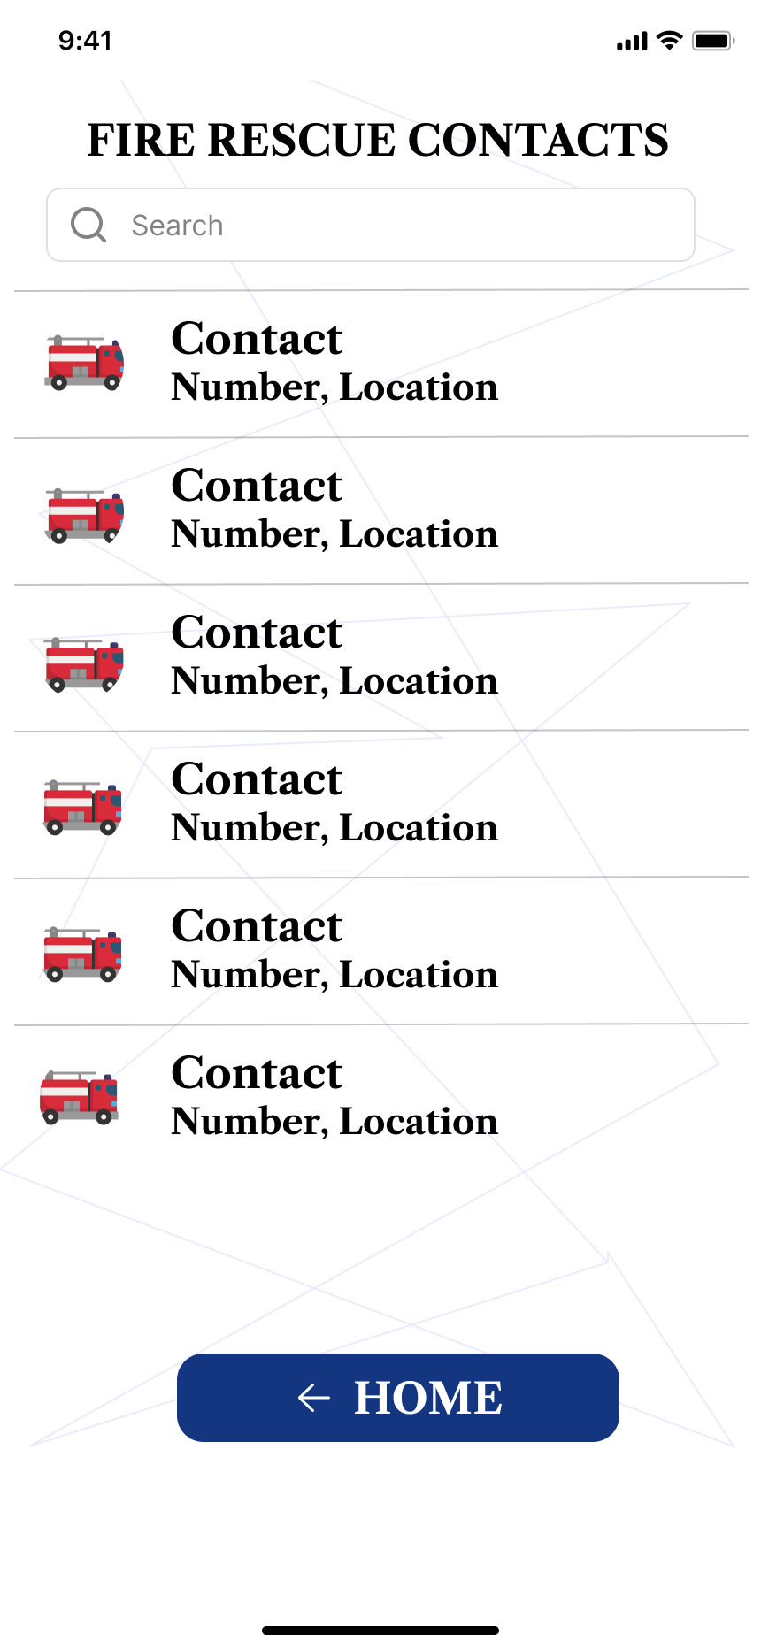

### 3.5.3 Hospital Contacts Screen

Users can find and contact nearby hospitals:

* **Elements**: List of hospitals with contact details and navigation options.
* **Design Focus**: Comprehensive list and easy navigation to nearest hospitals.
* **User Experience**: Helps users get medical attention promptly.

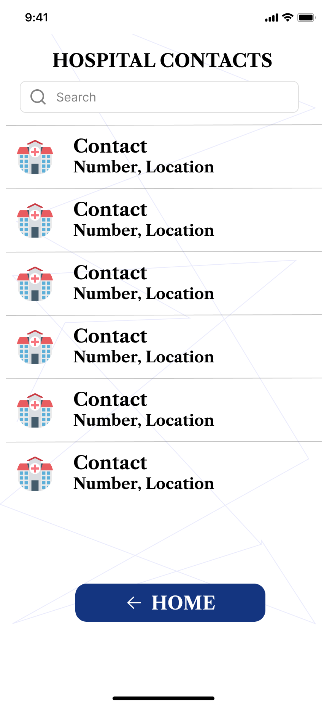

### 3.5.4 Police Contacts Screen

This screen lists police contacts:

* **Elements**: List of police stations with contact buttons.
* **Design Focus**: Easy access to law enforcement contacts.
* **User Experience**: Enables quick reporting of crimes and seeking assistance.

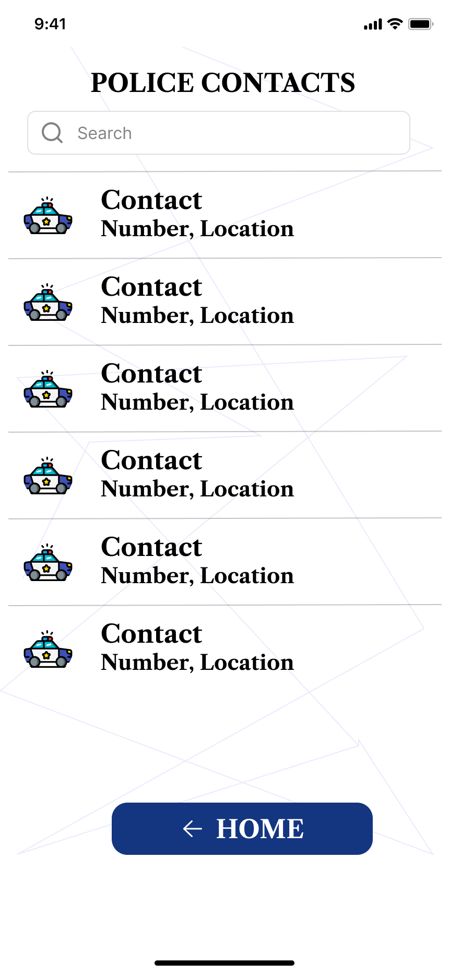

### 3.5.5 Alerts Screen

The alerts screen displays notifications about ongoing and upcoming emergencies:

* **Elements**: List of alerts with details and timestamps.
* **Design Focus**: Real-time updates and clear presentation of alerts.
* **User Experience**: Keeps users informed about current and potential threats.

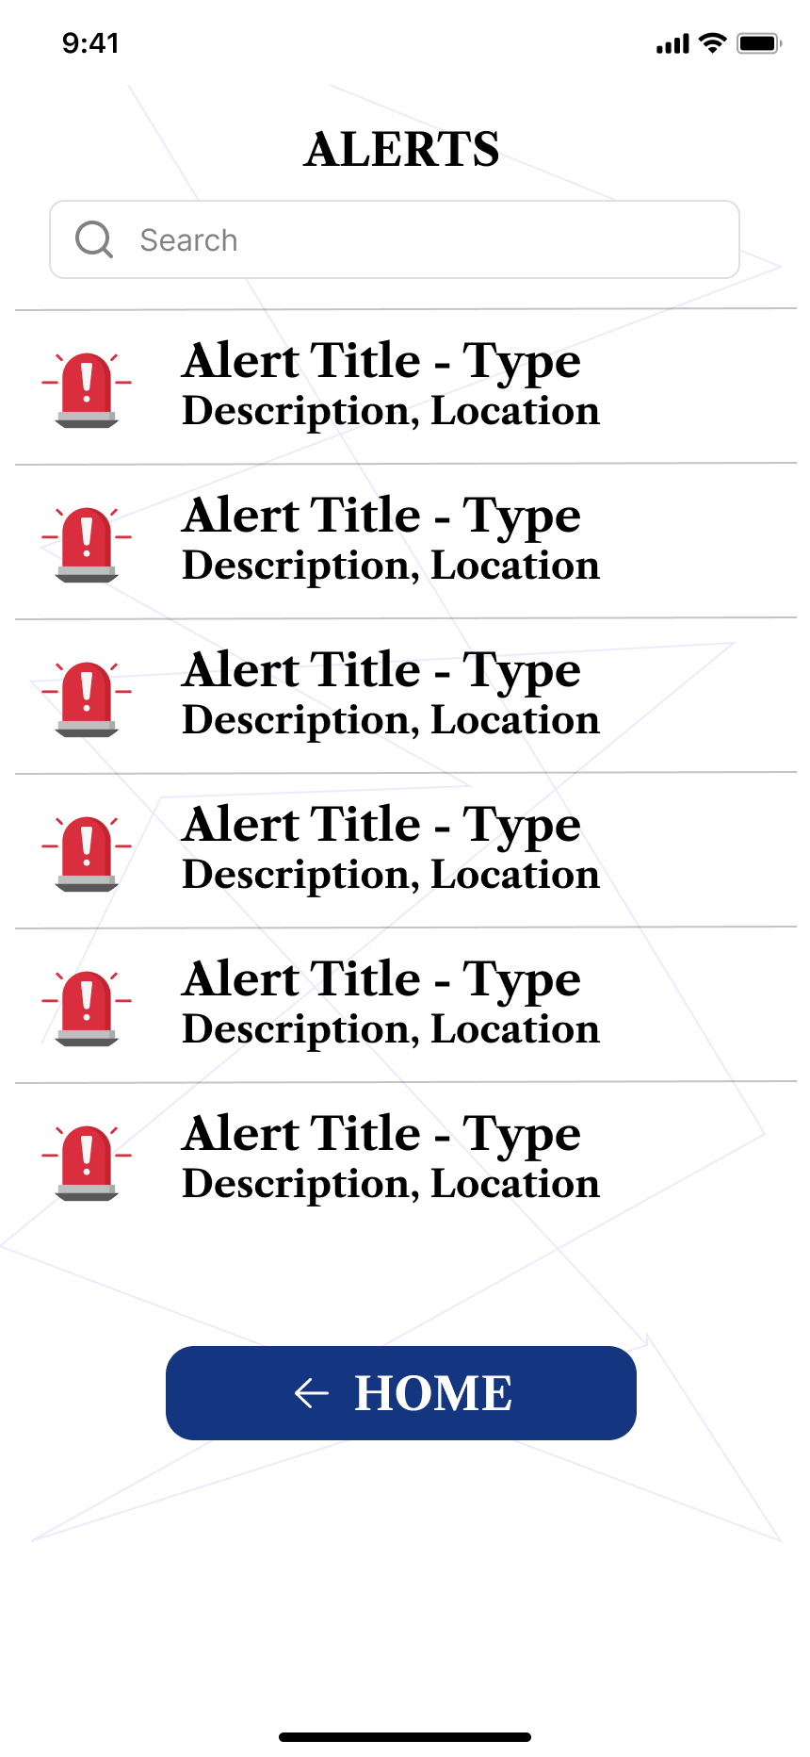

### 3.5.6 Safety Tips Screen

Users can access safety tips related to various disasters:

* **Elements**: Categorized safety tips with detailed instructions.
* **Design Focus**: Comprehensive and easily accessible information.
* **User Experience**: Helps users prepare and stay safe during emergencies.

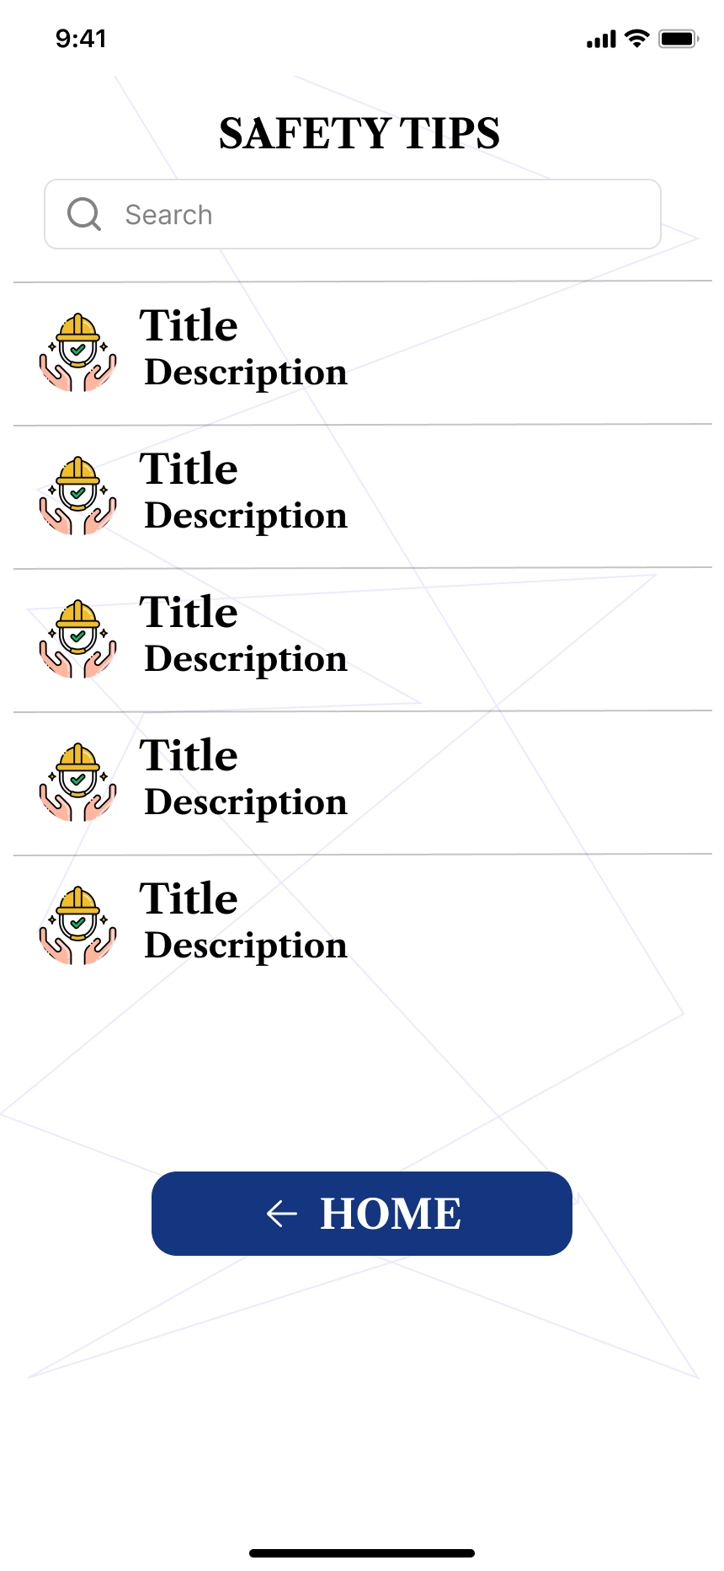

### 3.5.7 First Aid Tips Screen

This screen provides essential first aid tips:

* **Elements**: Step-by-step first aid instructions for common injuries and emergencies.
* **Design Focus**: Clarity and simplicity in presentation.
* **User Experience**: Empowers users to provide immediate assistance during medical emergencies.

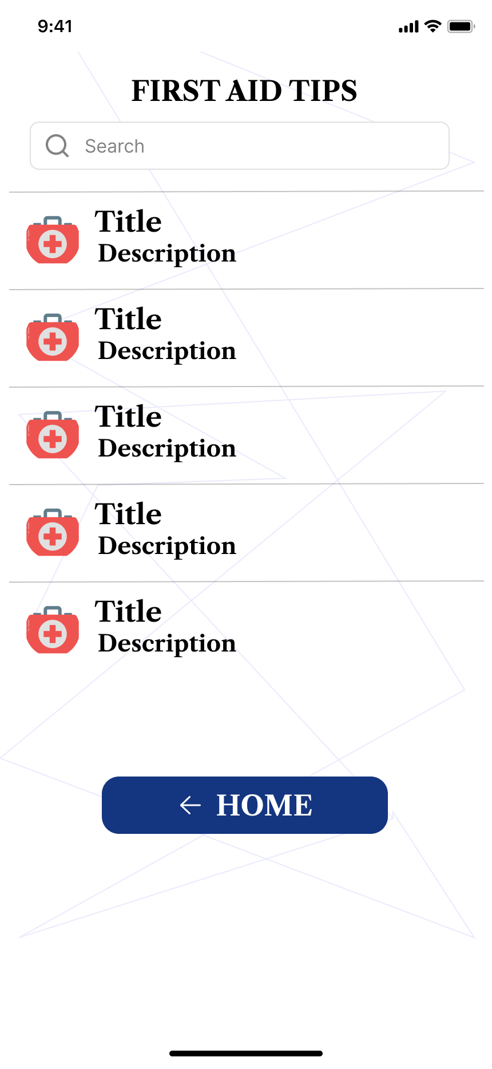

### 3.5.8 News Screen

The news screen keeps users updated with the latest news related to disasters:

* **Elements**: News feed with headlines and brief summaries.
* **Design Focus**: Timely and relevant information.
* **User Experience**: Keeps users informed about developments in disaster management.

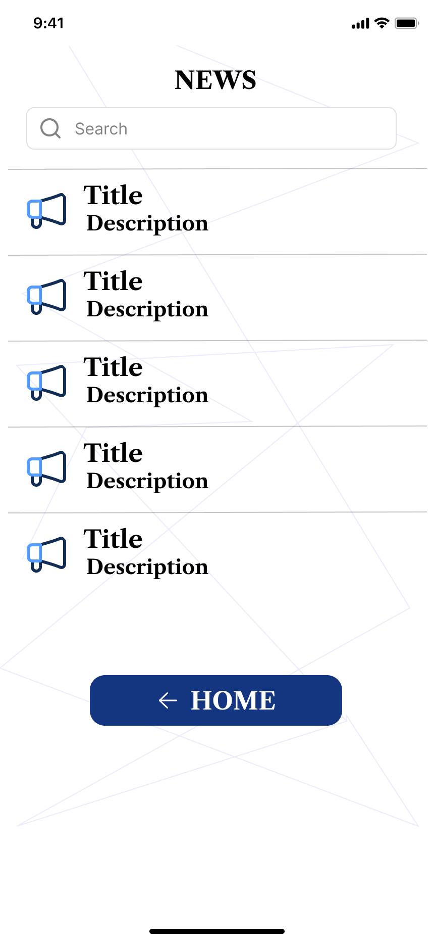

### 3.5.9 Emergency Preparations Screen

This screen offers guidelines and checklists for emergency preparations:

* **Elements**: Preparation tips, checklists, and resource links.
* **Design Focus**: Practical and actionable information.
* **User Experience**: Helps users stay prepared for potential disasters.

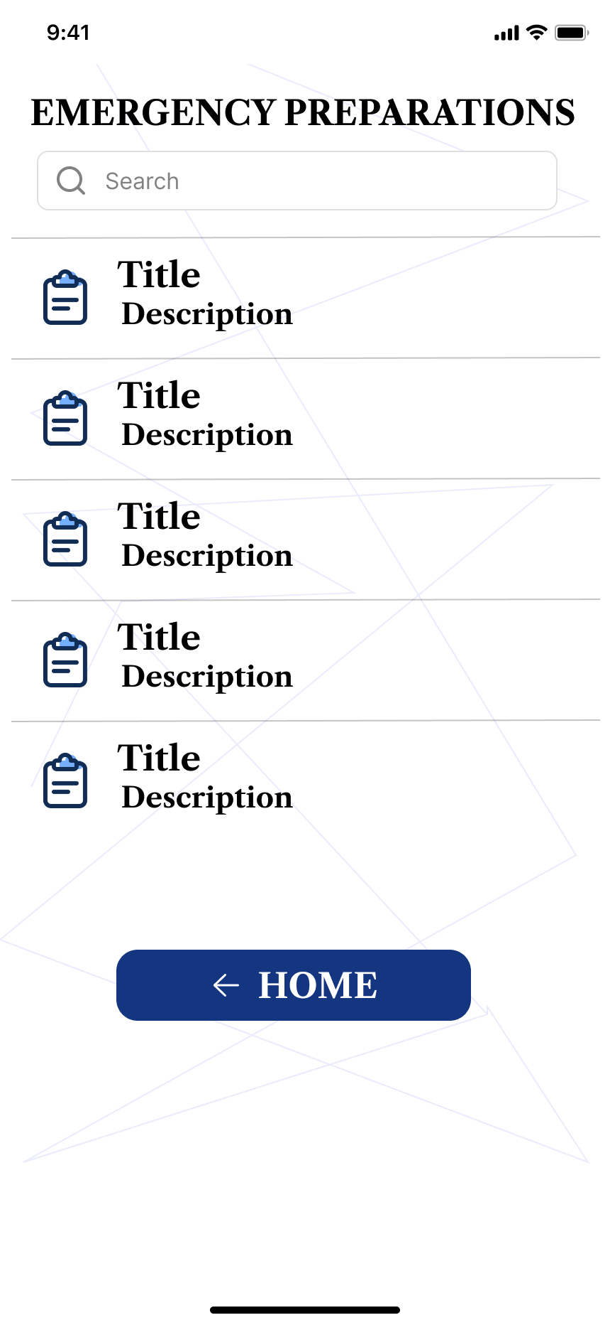

### 3.5.10 Report Status Screen

Users can report incidents and check the status of their reports:

* **Elements**: Report submission form and status tracker.
* **Design Focus**: Simple reporting process and transparent status updates.
* **User Experience**: Ensures users can report incidents easily and track their resolution.

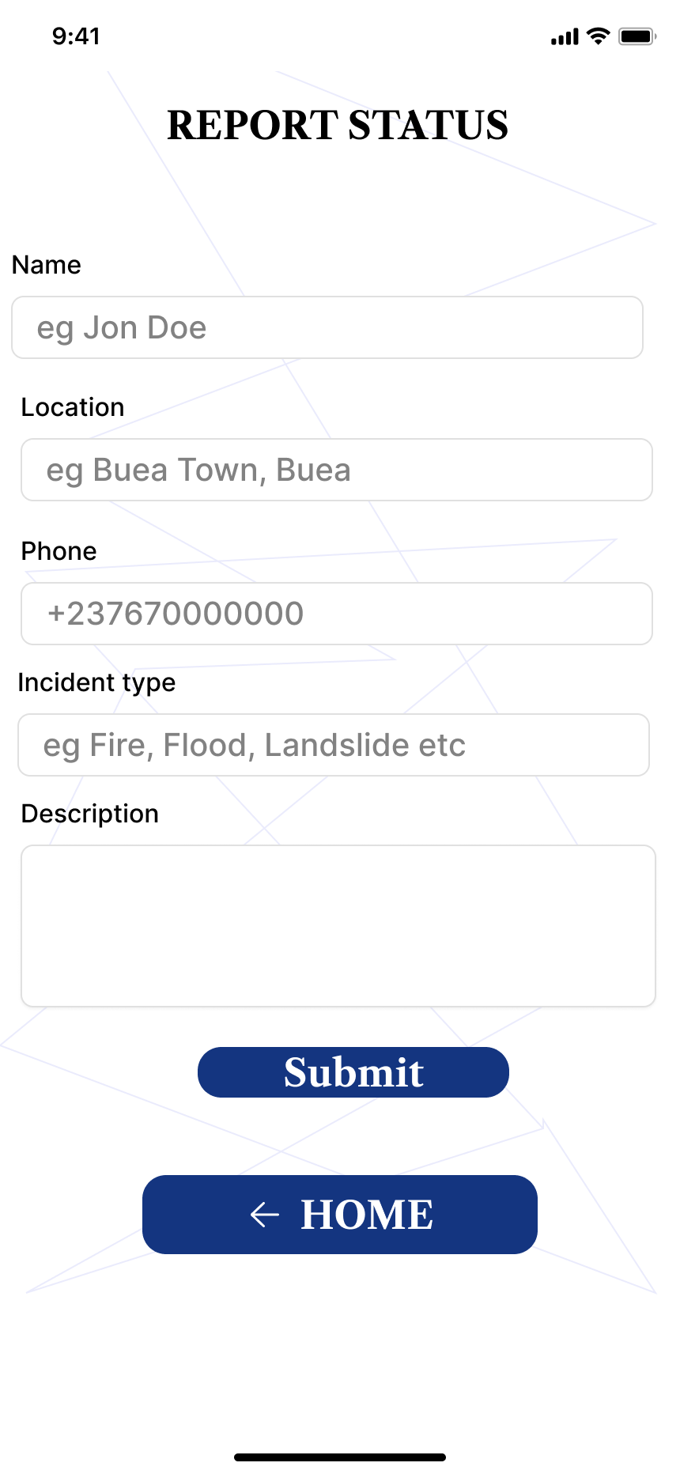

## 3.6 Respondents Dashboard Design

The respondents' dashboard focuses on managing reports and coordinating with teams:

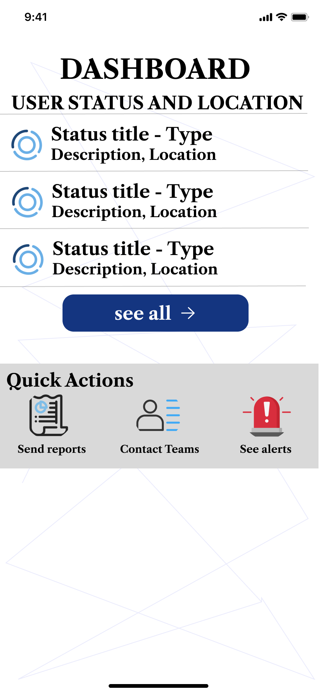

### 3.6.1 Send Reports Screen

Respondents can send detailed reports about incidents:

* **Elements**: Report submission form with fields for incident details.
* **Design Focus**: Comprehensive reporting options.
* **User Experience**: Facilitates accurate and detailed incident reporting.

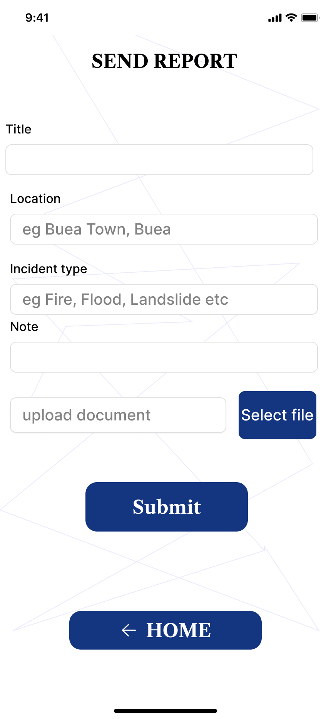

### 3.6.2 Contact Teams Screen

This screen allows respondents to contact their teams quickly:

* **Elements**: List of team contacts with communication options.
* **Design Focus**: Efficient team communication.
* **User Experience**: Supports quick coordination and response.

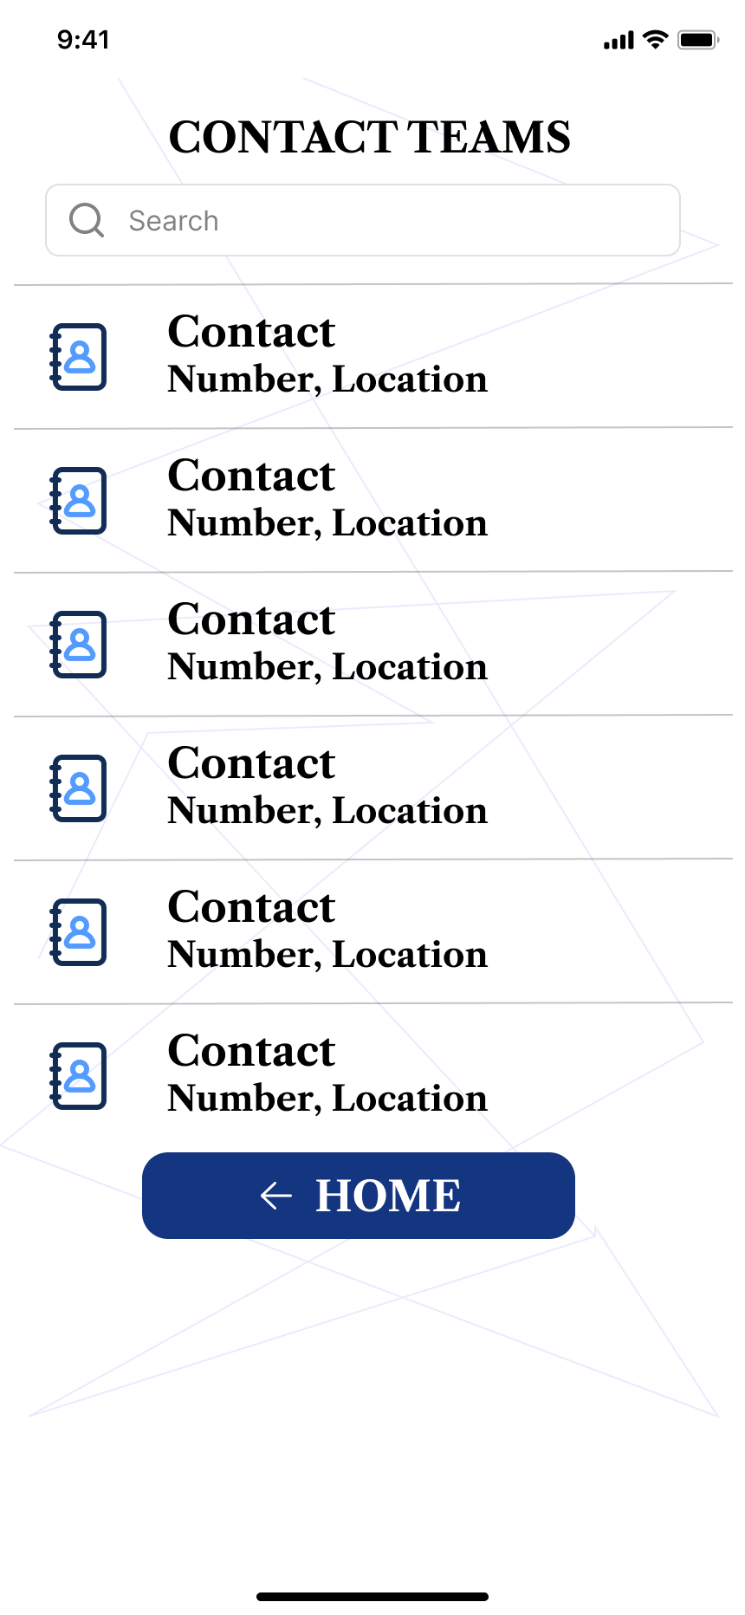

### 3.6.3 See Alerts Screen

Respondents can view alerts about ongoing emergencies:

* **Elements**: List of alerts with details and timestamps.
* **Design Focus**: Real-time updates and clear presentation of alerts.
* **User Experience**: Keeps respondents informed about current and potential threats.

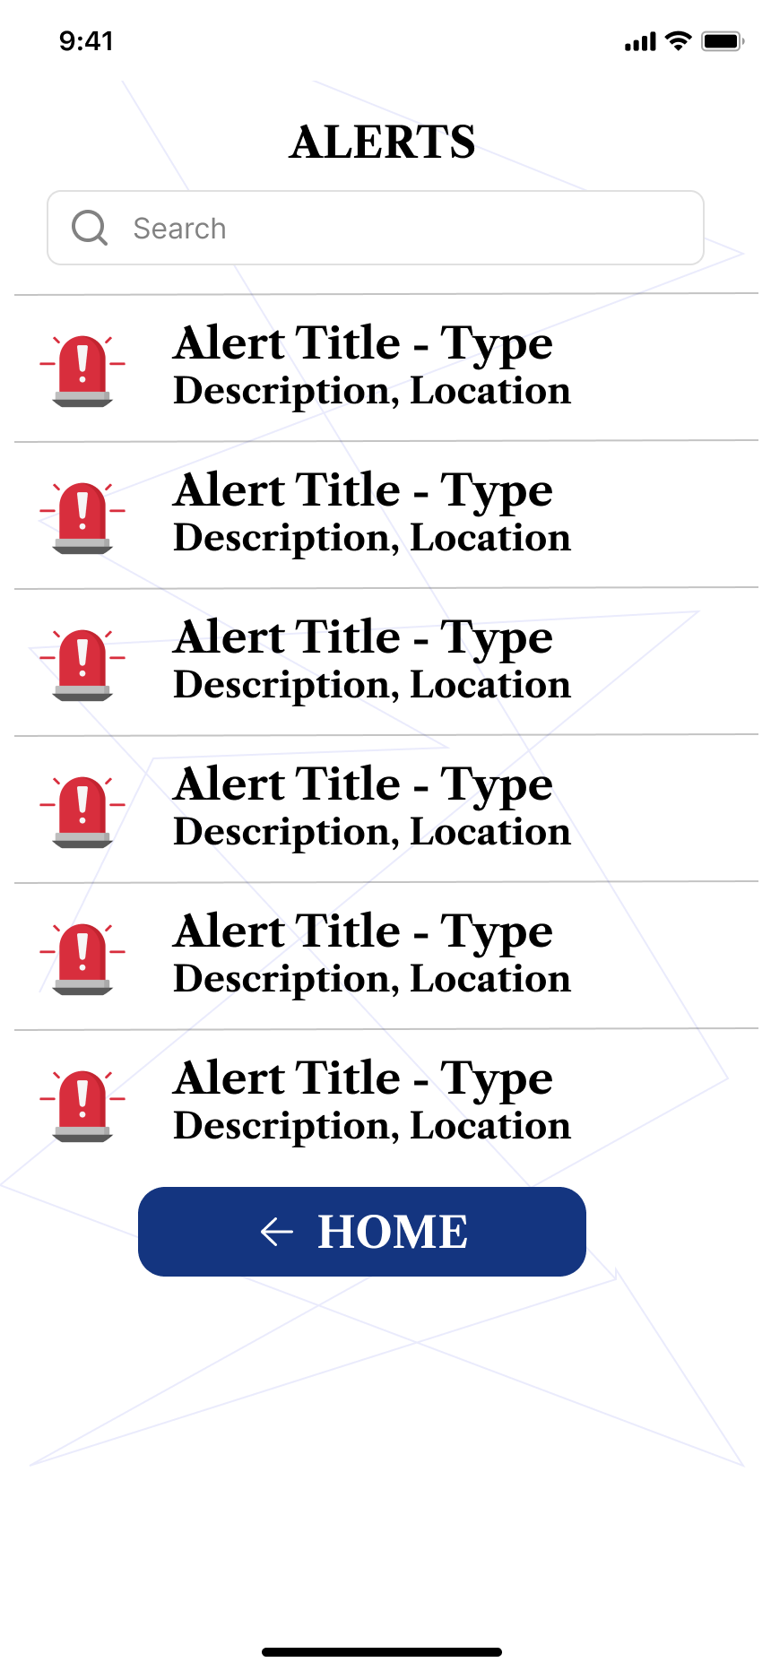

### 3.6.4 User Status and Location Screen

This screen shows the status and location of users who have reported incidents:

* **Elements**: Map view with user locations and status indicators.
* **Design Focus**: Real-time tracking and status updates.
* **User Experience**: Aids in effective rescue operations.

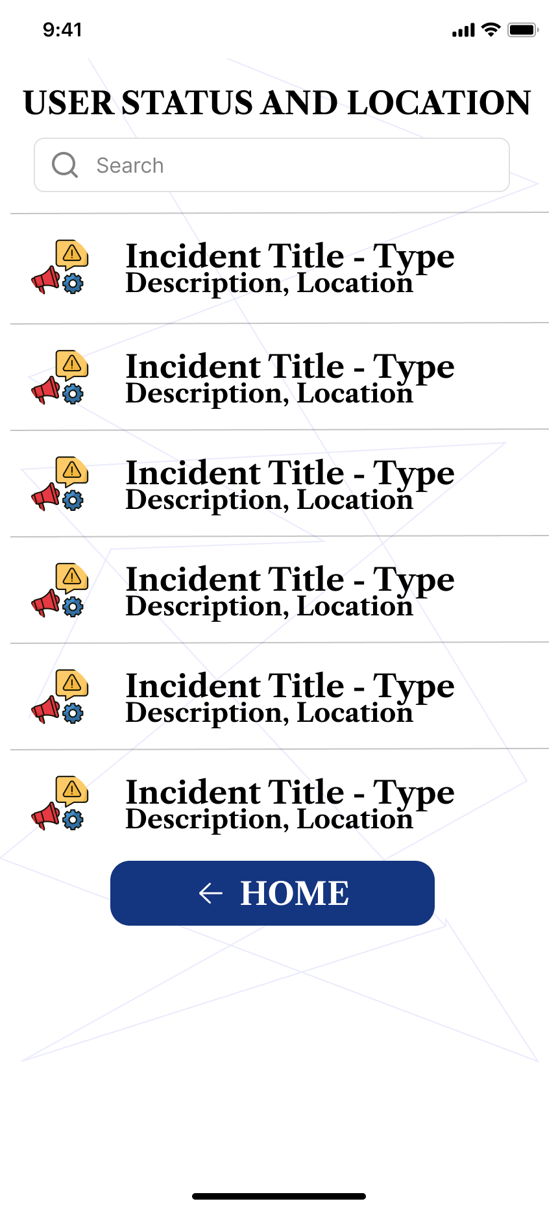

## 3.7 Authorities Dashboard Design

The authorities' dashboard is designed to manage alerts, directives, and reports:

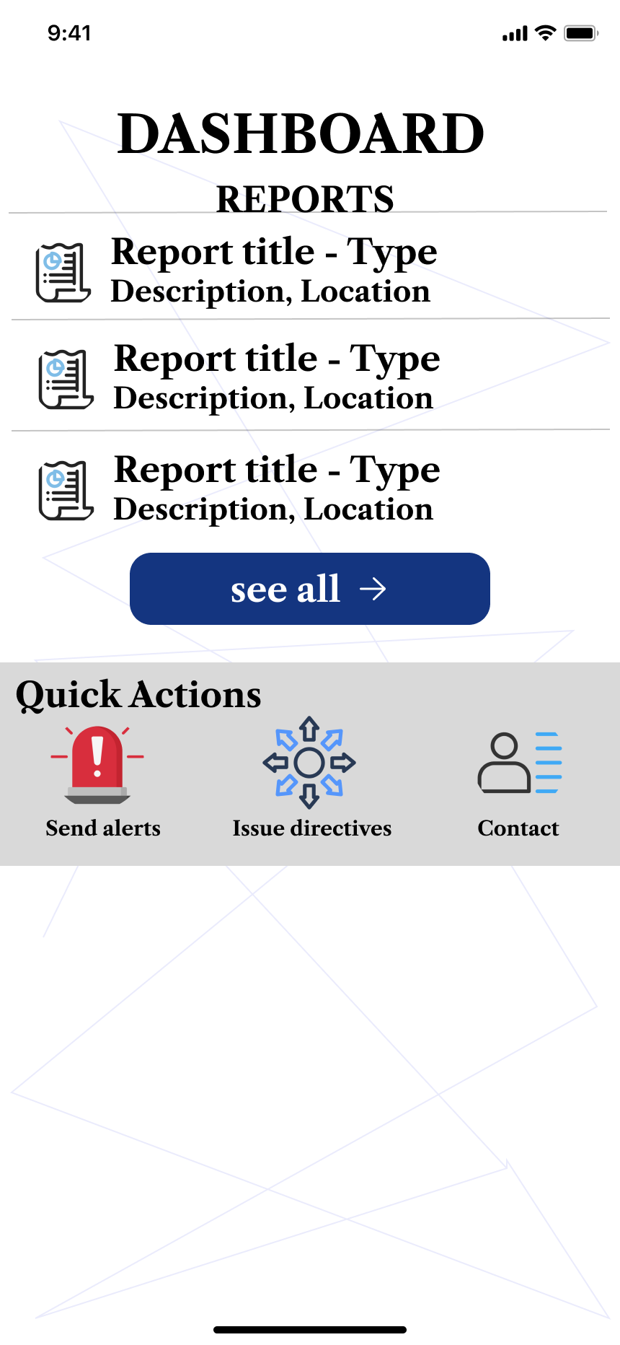

### 3.7.1 Send Alerts Screen

Authorities can send emergency alerts to users and respondents:

* **Elements**: Alert creation form with options for urgency and target audience.
* **Design Focus**: Quick and efficient alert dissemination.
* **User Experience**: Ensures timely communication of critical information.

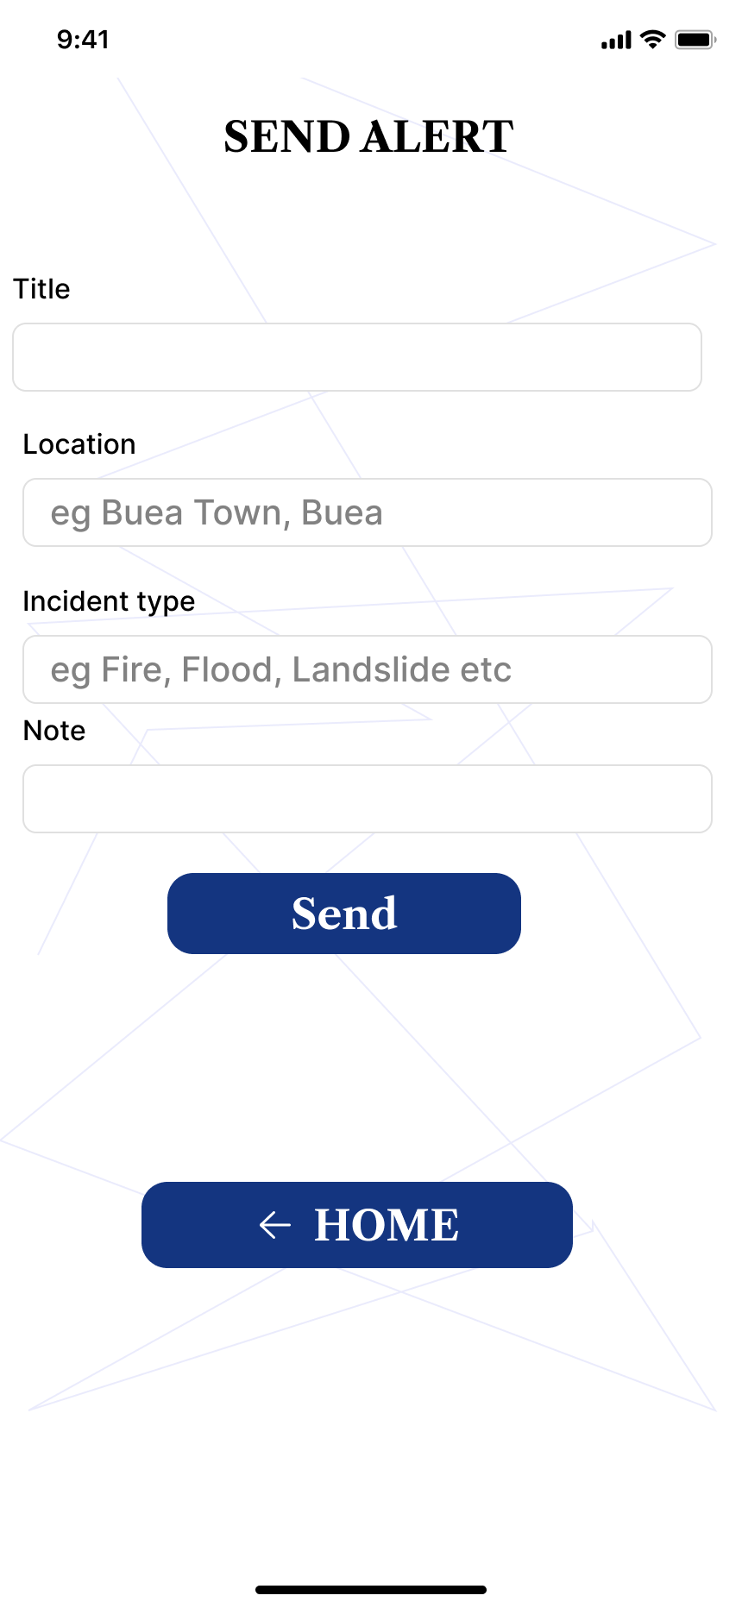

### 3.7.2 Issue Directives Screen

This screen allows authorities to issue directives during emergencies:

* **Elements**: Directive creation form with options for details and instructions.
* **Design Focus**: Clear and authoritative communication.
* **User Experience**: Facilitates effective management of emergency situations.

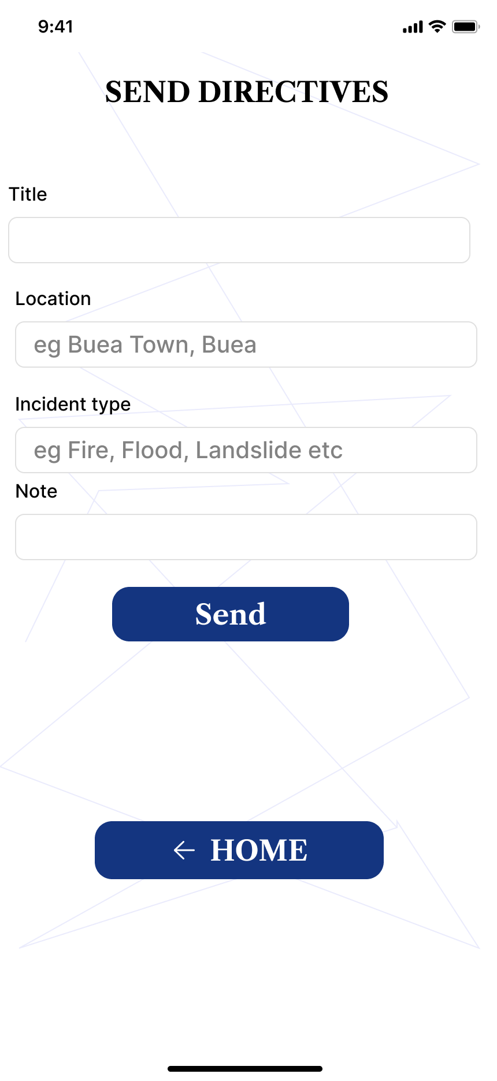

### 3.7.3 Contact Teams Screen

Authorities can contact various teams to coordinate disaster response efforts:

* **Elements**: List of team contacts with communication options.
* **Design Focus**: Efficient coordination and communication.
* **User Experience**: Supports streamlined management of response activities.

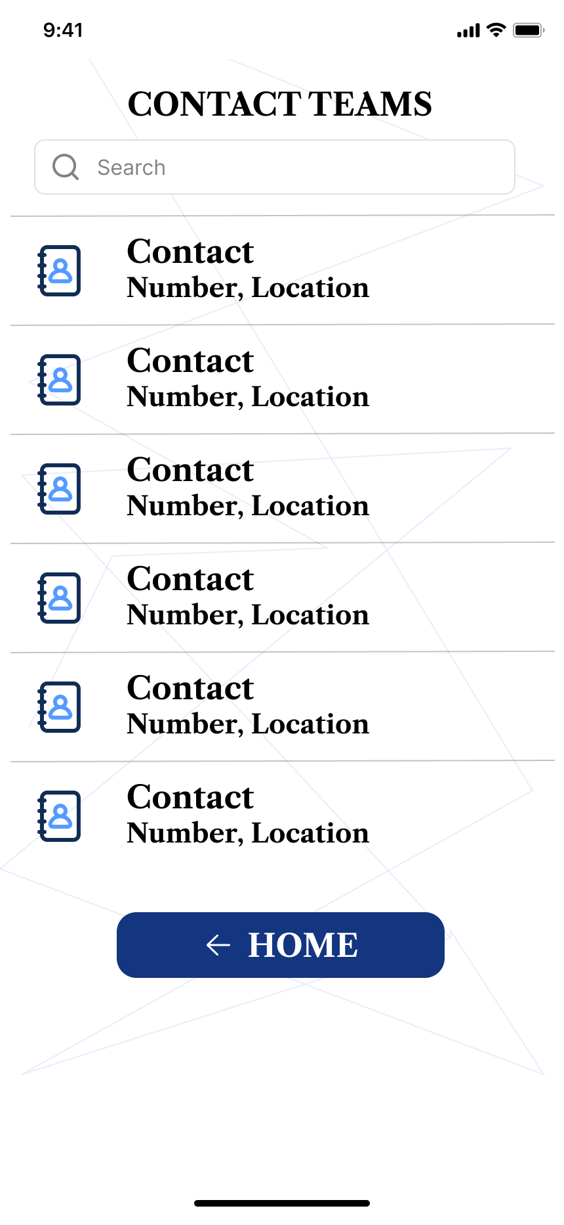

### 3.7.4 Reports Screen

Authorities can view and manage reports submitted by users and respondents:

* **Elements**: Report list with details and status updates.
* **Design Focus**: Comprehensive report management.
* **User Experience**: Ensures authorities can track and address incidents effectively.

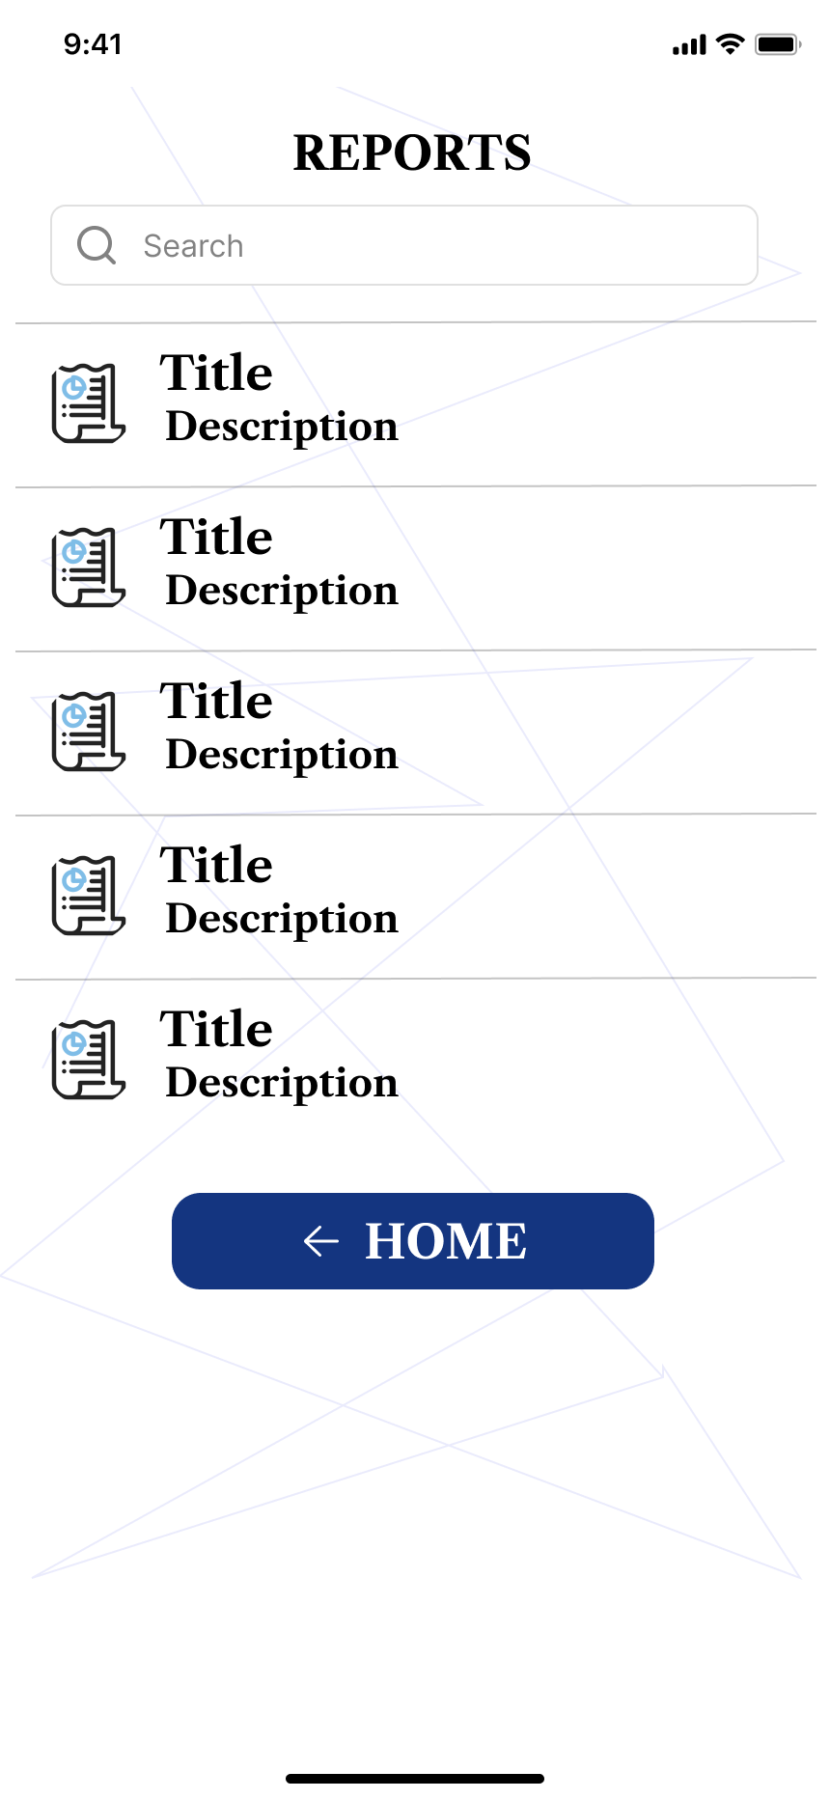

# 4. UI Implementation Strategy

The UI implementation strategy involves several key steps:

* **Development**: Using a cross-platform framework like Flutter to build the app, ensuring consistency across different devices and operating systems.
* **Testing**: Conducting thorough testing, including usability testing, functional testing, and performance testing, to ensure the app is reliable and user-friendly..
* **Maintenance**: Regularly updating the app to improve functionality, fix bugs, and enhance the user experience based on ongoing feedback and technological advancements.

# 5. Coding

A link to the code of our design was uploaded to github which can be found in the link below;

<https://github.com/duesenberry55/CEF440-group-20/tree/main/dmsg20>

# 6. Conclusion

The UI design and implementation of the disaster management mobile application are crucial in enhancing the efficiency and effectiveness of disaster response. By focusing on usability, accessibility, and functionality, the app ensures that users, respondents, and authorities can navigate and use the app efficiently during emergencies. The collaborative design process using Figma and the strategic implementation plan ensure that the app meets the needs of all stakeholders involved in disaster management.

# 7. Technologies

* Figma for the design
* Flutter and dart for the front-end implementation